SIH 26130 — Maharashtra Industrial Approvals Platform
Complete feature specification and system architecture

1. Overview
This document consolidates every feature planned for the platform into one build-ready reference, adds six features not covered in earlier drafts — a predictive timeline estimator plus five features that close gaps against the official SIH expected outcomes (regulatory knowledge engine, risk-based scrutiny, a customised checklist generator, a schemes and incentives matcher, and coordinated inspection planning) — and lays out the system architecture the web app will be built on. The platform supports English and Marathi. It targets the gap MAITRI 1.0/2.0 leaves open: self-certification currently covers only part of the ~13 approvals, department backends remain unintegrated behind a unified front-end form, and MSMEs/first-time applicants still lean on agents rather than self-serving confidently. Every feature below is designed to close one specific piece of that gap.

2. Complete Feature List
Features are grouped by the platform module they belong to, so a development team knows exactly where each one lives. Newly added features (not in the earlier feature doc) are marked New.

2.1 Applicant-facing features
Feature | What it does
Unified single-window portal | One login and one base form for all industrial approvals, replacing department-by-department portals.
Customised approval checklist (New) | Generates the exact list of approvals and documents needed, based on the applicant's industry type, location, and scale — instead of the applicant guessing from a static list.
OCR-based auto-fill | Reads uploaded documents (PAN, land deed, ID proof) and pre-fills form fields, cutting repeat data entry.
Smart document wallet | Stores verified documents once, with expiry tracking and renewal reminders, for reuse across future applications.
Missing-document / duplicate detector | Flags incomplete submissions and duplicate uploads before submission, not after department review.
Real-time tracking dashboard | Shows live status, current department, and expected next step for every application.
Language and format normalization | Supports the application in English and Marathi, and normalizes uploaded document formats for uniform backend processing.
Public leaderboard | Publishes department turnaround times and applicant ratings for transparency.
Self-certification / green channel | Lets low-risk, high-trust applicants self-certify instead of waiting for full manual review.

2.2 Intelligence and automation features
Feature | What it does
AI classification and routing engine | Classifies each uploaded document and routes the application to the correct department(s) using confidence thresholding, with human fallback for low-confidence cases.
One-click multi-department dispatch | Sends a single verified application packet to every relevant department at once, instead of sequential re-submission.
Continuous feedback loop | Officer corrections on misclassified documents feed back into the model to improve routing accuracy over time.
Predictive timeline and bottleneck estimator (New) | Uses historical department-level processing data to give applicants a realistic ETA per approval and flags which department is currently the bottleneck for their case.

2.3 Trust, security and compliance features
Feature | What it does
Role-based access control | Restricts data visibility by role — applicant, officer, department admin, auditor.
Document authenticity and tamper detection | Cross-checks uploaded documents against source systems (e.g. DigiLocker) where available.
Grievance redressal module | Structured complaint flow with a 30-day SLA tracker and escalation path, as a backstop to real-time tracking.
Audit trail and version history | Every action on an application (upload, edit, review, approval) is logged and time-stamped.
Encryption at rest and in transit | All applicant documents and personal data are encrypted end-to-end.

2.4 Department / officer-facing features
Feature | What it does
Officer-side smart search | Lets officers search applications by applicant, document type, or status across the unified backend.
Unified backend queue | Auto-routed applications arrive pre-sorted and pre-verified, removing duplicate manual checks.
Priority flagging | Applications nearing SLA breach or flagged high-risk are surfaced first in the officer queue.
Departmental feedback and rating capture | Applicants rate their experience per department after each approval, feeding the public leaderboard with real data.

2.5 Access and inclusion features
Feature | What it does
Assisted / agent mode | A guided, simplified flow for MSMEs and first-time applicants who currently rely on consultants.
Remote/video verification | For low-risk, high-trust-score units, a video-call inspection replaces an in-person visit for eligible approval types.
Multi-unit enterprise view | A company with several factories across Maharashtra gets one consolidated dashboard instead of managing each unit separately.

2.6 Regulatory, risk and schemes features (New)
These four features exist specifically to close gaps against the official SIH expected outcomes — none of them were in the earlier drafts.
Feature | What it does
Regulatory knowledge engine | A rules database mapping unit type, location, and scale to the exact regulations and approvals that apply — the source of truth the checklist generator and the routing engine both read from.
Risk-based scrutiny score | Scores each application by risk (unit type, history, trust score) to decide how deep a review it needs — the explicit mechanism behind self-certification and the officer priority queue.
Schemes and incentives matcher | Matches an applicant's profile against active government schemes and incentives they're eligible for, and tracks their claims alongside approvals and renewals on the same dashboard.
Coordinated inspection planning | When multiple departments need to inspect the same site, bundles those inspections into a single scheduled visit instead of three separate ones.

3. Why the new features earn their place
Each addition was chosen because it solves a problem visible either in the current-state analysis or in the official SIH expected-outcomes text, and wasn't addressed by any feature in the earlier drafts.
- Predictive timeline and bottleneck estimator — It turns "mandatory digital, not confidently used" into something usable: MSMEs today can't tell how long an approval will actually take, which is exactly why they fall back on agents. A predictive ETA, grounded in real department data rather than a fixed SLA number, gives them a reason to trust the self-serve flow.
- Customised approval checklist — The SIH brief explicitly asks for a system that can generate a customised checklist, not just let applicants pick from a list. Without this, applicants still have to know what they need before the platform can help them.
- Regulatory knowledge engine — Routing documents to the right department (already built) isn't the same as knowing which regulations apply to a given unit in the first place. This engine is the piece that makes the checklist generator and smarter routing possible, and it's named explicitly in the SIH brief.
- Risk-based scrutiny score — Self-certification already exists, but nothing made explicit how the platform decides who qualifies. Naming the risk score directly means it can be reasoned about, audited, and tuned — and it's called out by name in the expected solution.
- Schemes and incentives matcher — Two of the SIH's stated outcomes — "better utilisation of government schemes" and a dashboard covering "renewals and incentives" — had no matching feature anywhere in the earlier drafts. This was the largest gap.
- Coordinated inspection planning — Remote/video verification covers single-department, low-risk cases. This covers the opposite case: several departments needing to inspect the same site, which today means three separate visits instead of one coordinated one — directly named in the SIH brief as "common inspection planning."

4. Web App Architecture
The system is organized into seven layers plus the external systems it integrates with. Each layer has a single responsibility, so the intelligence layer (classification, OCR, fraud checks) and the new regulatory/risk/schemes layer can evolve independently of the application services or the client surfaces.
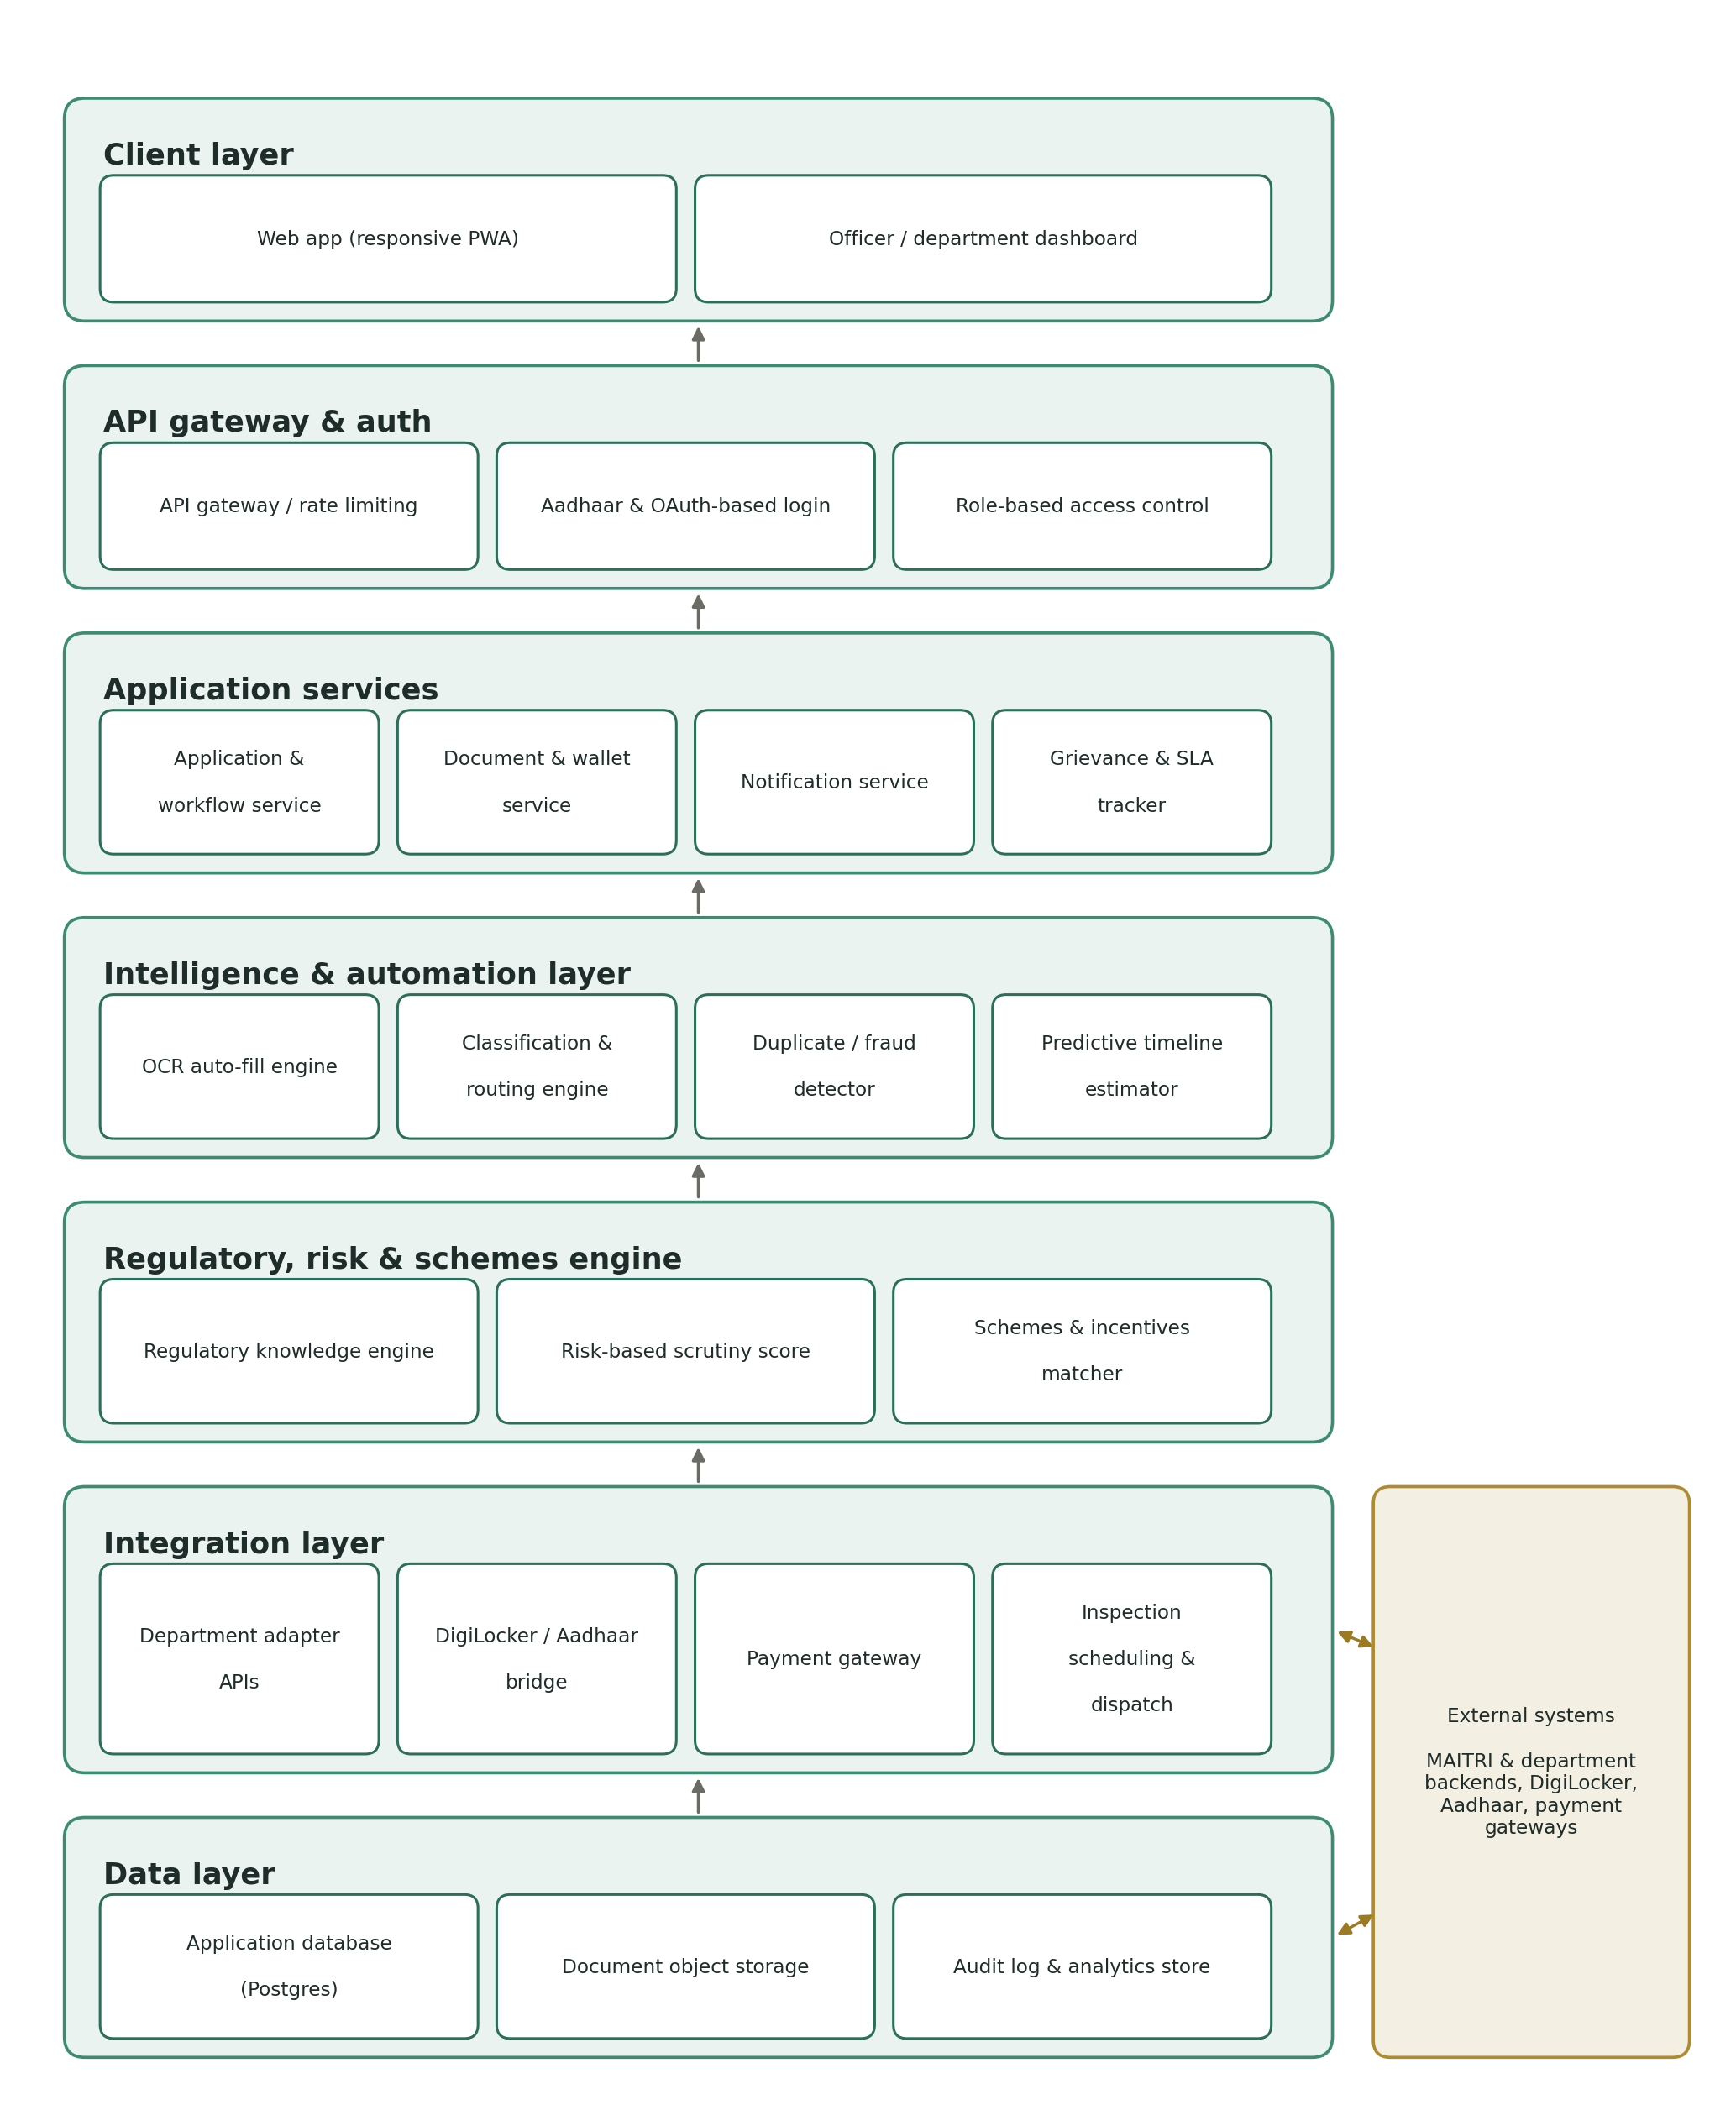

4.1 Layer responsibilities
- Client layer — The web app (responsive PWA), built for English and Marathi, plus the officer/department dashboard — two surfaces, one backend.
- API gateway and auth — Single entry point for all traffic; handles Aadhaar/OAuth-based login and role-based access control before any request reaches a service.
- Application services — Owns the application workflow, the document wallet, notifications, and the grievance/SLA tracker — the services an applicant's request actually moves through.
- Intelligence and automation layer — OCR auto-fill, the classification and routing engine, the duplicate/fraud detector, and the predictive timeline estimator. This is the layer that removes manual work from both applicants and officers.
- Regulatory, risk and schemes engine — The regulatory knowledge engine, the risk-based scrutiny score, and the schemes/incentives matcher — the layer that decides what applies, how much scrutiny it needs, and what an applicant is eligible for, feeding the checklist generator and the officer priority queue.
- Integration layer — Adapter APIs per department, a DigiLocker/Aadhaar bridge, the payment gateway, and inspection scheduling and dispatch — everything that talks to a system outside the platform.
- Data layer — Postgres for structured application data, object storage for documents, and a separate audit-log/analytics store so compliance queries never compete with production traffic.
- External systems — MAITRI and individual department backends, DigiLocker, Aadhaar, and the payment provider — systems the platform integrates with but does not own.

4.2 Design principles behind the layering
- Department backends stay untouched; the integration layer absorbs their quirks through adapters, so onboarding a new department never means changing the core application service.
- The intelligence layer is stateless and callable independently, which is what makes the feedback loop (officer corrections improving the model) possible without redeploying the whole app.
- Every write to the data layer also writes to the audit log, so the compliance features in section 2.3 are enforced structurally, not bolted on.

5. Closing note
Together, sections 2 through 4 give a development team the full feature scope, the reasoning for the new additions, and the architecture to build against — a single reference that carries this idea from problem statement to build, now aligned against the official SIH expected outcomes.

